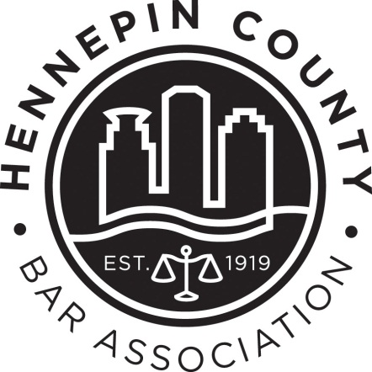

1L Minority Clerkship Program
2017 Employer Information

Program Overview:
The HCBA 1L Minority Clerkship Program first began in the fall of 2005 under the direction of the Minnesota State Bar Association. The program places first-year racial minority law students with Minnesota legal employers for a summer associate experience. The goal of the program is to bring together qualified racial minority law students and larger legal employers in Minnesota. Ultimately, the program hopes to find its participants becoming future partners and leaders in Minnesota’s larger legal employer community.
For the first summer experience in the summer of 2006, 24 first-year law students worked with 24 legal employers. Since then, the program has experienced great success. The 2016 summer was the program’s tenth year, where over 44 students applied and 9 students were placed. Hundreds of law students from underrepresented backgrounds have been served by the program since its inception.

Here Is How It Works:
Each 1L law student, who provides a complete application and who self-identifies as a minority under the EEOC definition of minority, will be interviewed by members of the HCBA Diversity Committee and other volunteer attorneys in early January. A limited number of students (based on the number of participating employers) will be chosen for a second round of interviews in early February. Those students chosen for the second round of interviews are guaranteed summer employment. However, they will still need to interview with all the participating employers during a day-long interview process. The employers and students will rank their choices from first to last. The program chair will then generate a blind match of employer and students which will determine the employment matches for the clerkship program.

If participating in the Summer 2017 program, please take note of the following:
Though not required, employers are strongly encouraged to provide a representative to serve on the 1L Selection Committee. This committee is tasked with reviewing applicant materials, interviewing students, and selecting finalists.

Members of the 1L Selection Committee must attend the following:
- Interviewer Training/Question Development (1-hour): mid-December
- At least one first-round interview shift (2-hours): first full week of January
- Selection meeting (3-hours): third week of January

IMPORTANT PROGRAM DATES

Nov. 1-30 Information sessions are held at each Twin Cities Law School

Jan. 9 - 13 1L Selection Committee: First Round Interviews (3:00pm to 7:00pm)
*Shifts are 3:00pm – 5:00pm and 5:00pm – 7:00pm @ HCBA
Jan. 19 1L Selection Committee: Selection Meeting (3:00pm to 6:00pm)
Feb. 3 Matching Day Interviews (8:30am to 4:30pm)

Feb. 8 Employer Preference Forms Due

Feb. 17 Matches announced

Summer Clerkships are 8-12 weeks long. The start and end date is up to the employer.

2016 Summer Employers
- Arthur Chapman
- Bowman and Brooke
- Dorsey & Whitney
- Fredrikson & Byron
- Hennepin County Attorney’s Office
- Hennepin County Public Defender’s Office
- Lockridge Grindal Nauen
- Minnesota Dept. of Commerce
- Minnesota Dept. of Transportation

To learn more or to commit to participating, contact Dana Rindahl at dana@hcba.org or 612-752-6627.

